Burton and Dalby Neighbourhood Plan Referendum. Information Statement
A Referendum relating to the adoption of the Burton and Dalby Neighbourhood Plan will be held on Thursday, 1st December 2022.
The question which will be asked in the Referendum is:
“Do you want Melton Borough Council to use the Neighbourhood Plan for Burton and Dalby to help it decide planning applications in the neighbourhood area?”
The Referendum area is identified on the map below. The Referendum area is identical to the area which has been designated as the Burton and Dalby Neighbourhood area.
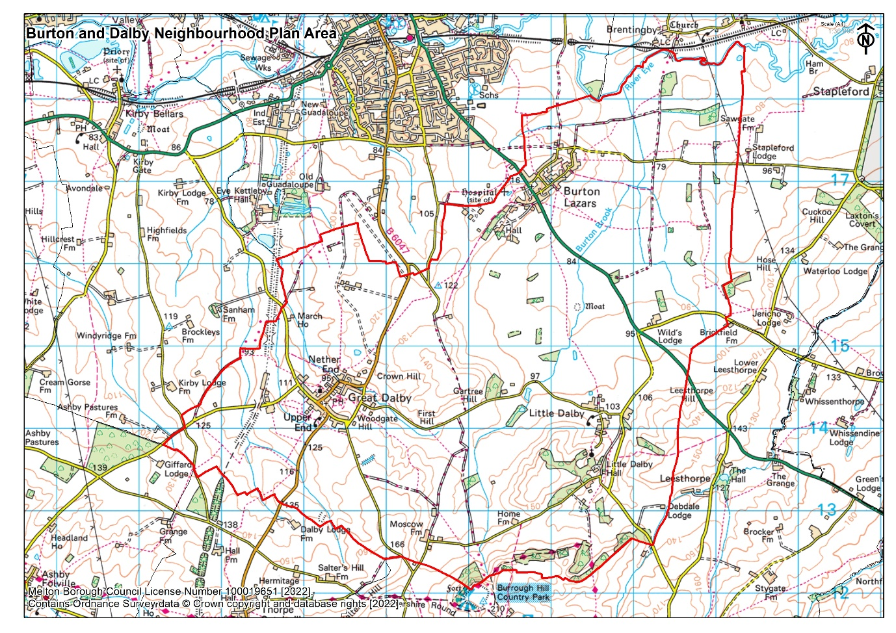
A person is entitled to vote in the Referendum if on 1st December 2022:
- he or she is entitled to vote in a local government election in the Referendum area; and
- his or her qualifying address for the election is in the Referendum area. A person’s qualifying address is, in relation to a person registered in the Register of Electors, the address in respect of which he or she is entitled to be registered.
The Referendum expenses limit that will apply in relation to the Referendum is £2,362.00 plus (0.059 x number of entries in the register) and the number of persons entitled to vote in the Referendum by reference to which that limit has been calculated is 838. Polling Stations will be open from 7am till 10pm and normal election rules will be observed.
For more information about postal and proxy voting, please see the Notice of Referendum.
The finished Plan must be accepted by a majority vote for the area before it can be adopted, if more than 50% of electors voting in the referendum support the Neighbourhood Plan it will be adopted.
A copy of the specified documents, that is those listed below, may be accessed on the Council’s website using the following link: https://www.meltonplan.co.uk/burtonanddalby.
In order to reduce our carbon footprint and address the Covid-19 pandemic, we encourage the use of the digital documents, however, if you have difficulty accessing the Neighbourhood Plan and associated documents please contact our planning policy team at planningpolicy@melton.gov.uk to discuss a solution to suit your circumstances.
The specified documents are:
- The Burton and Dalby Neighbourhood Development Plan;
- Report of the independent examiner;
- Documents Submitted with the Neighbourhood Plan
- Statement by the local planning authority that the draft plan meets the basic conditions and complies with relevant legislation;
- This information statement;
- Further general information about town and country planning and the referendum may be accessed on the Council’s website using the following link - https://www.meltonplan.co.uk/neighbourhood-plans

