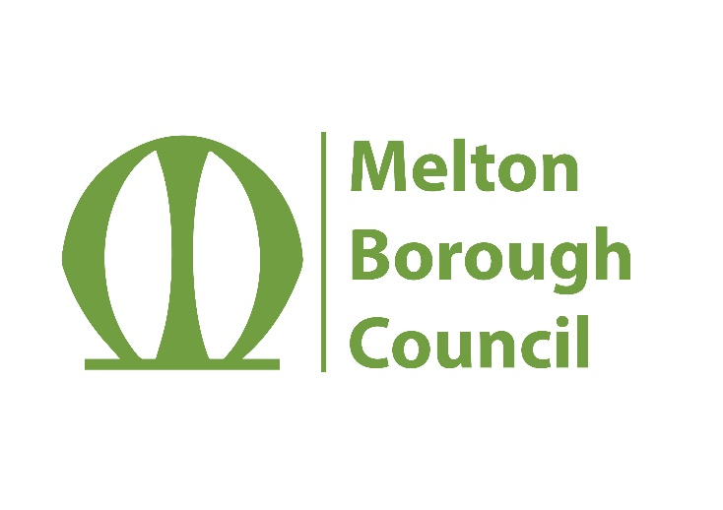
Melton Borough Council

Burton and Dalby Neighbourhood Development Plan
Basic Conditions and Compliance Statement

Melton Borough Council is satisfied that the Burton and Dalby Neighbourhood Development Plan as modified (Referendum Version):

- meets the basic conditions (as set out in paragraph 8(2) of Schedule 4B to the Town and Country planning Act 1990); and

- is not considered to breach or otherwise be incompatible with any EU obligation or any of the Convention rights (within the meaning of the Human Rights Act 1998); and

- complies with the provision concerning neighbourhood development plans made by or under Sections 38A and 38B of the Planning and Compulsory Purchase Act 2004.

Signed: 21/September/2022

Jorge Fiz Alonso
Senior Planning Policy Officer
Melton Borough Council

