Melton Borough Council interactive map – Tree Preservation Orders in Somerby Parish (2019)

SOMERBY VILLAGE
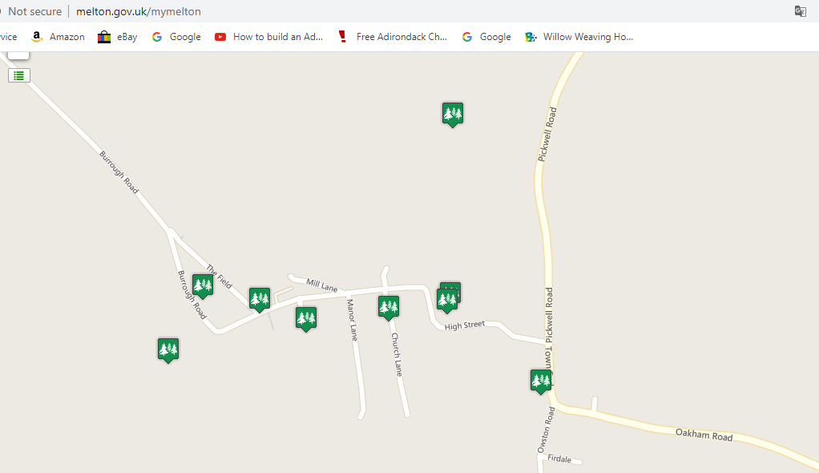
151.920.2?
151.920.6
151.920.7
151.920.2
151.920.4
151.920.8
151.920.5
151.920.3
151.920.1

Name | Area
Distance | 2.12 miles
Address | The Grove 1 Burrough Road Somerby LE14 2PP
Description | Area  Ref: 151/920/1
Website | 05/00130/TPOMBC

Name | Area
Distance | 1.66 miles
Address | High Street Somerby
Description | Area  Ref: 151/920/2
Website | 05/00129/TPOLCC
 | Neighbourhood Plan: This is Somerby Hall historic parkland
Name | Tree(s)
Distance | 1.52 miles
Address | Romond 16 High Street Somerby LE14 2PZ
Description | Beech  Ref: 151/920/2
Website | 05/00125/TPOMBC
 | Neighbourhod Plan: This entry must be in error. Reference 151/920/2 is Somerby Hall Parkland (above). There is only one beech tree at 16 High Street and that is protected under 151/920/6 (below).

Name | Area
Distance | 2.07 miles
Address | Grove Stud Burrough Road Somerby Melton Mowbray LE14 2PP
Description | Area  Ref: 151/920/3
Website | 05/00128/TPOMBC

Name | Tree(s)
Distance | 1.65 miles
Address | The Three Crowns Inn 39 High Street Somerby LE14 2PZ
Description | Holly  Ref: 151/920/4
Website | 05/00127/TPOMBC

Name | Tree(s)
Distance | 1.94 miles
Address | Somerby Methodist Church High Street Somerby Melton Mowbray LE14 2PZ
Description | Holly  Ref: 151/920/5
Website | 05/00124/TPOMBC
Name | Tree(s)
Distance | 1.53 miles
Address | 16 High Street Somerby
Description | Copper Beech  Ref: 151/920/6
Website | http://www.melton.gov.uk/downloads/file/1245/1519206_16

Name | Tree(s)
Distance | 1.29 miles
Address | 4 Town End Somerby
Description | Ash  Ref: 151/920/7
Website | http://www.melton.gov.uk/downloads/file/1239/1519207_4_

Name | Tree(s)
Distance | 1.83 miles
Address | Claremont Cottage 2 Chapel Lane Somerby LE14 2PR
Description | Holly  Ref: 151/920/8
Website | 07/00002/TPO

BURROUGH ON THE HILL
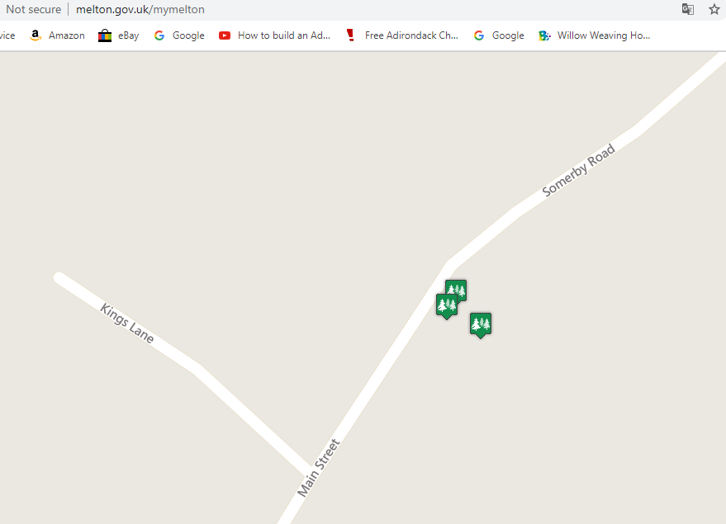

Name | Tree(s)
Distance | 3.15 miles
Address | The Old School 54 Main Street Burrough On The Hill LE14 2JQ
Description | Ash  Ref:
Website | 13/00002/TPO

Name | Tree(s)
Distance | 3.15 miles
Address | The Old School 54 Main Street Burrough On The Hill LE14 2JQ
Description | Ash  Ref:
Website | 13/00002/TPO

Name | Tree(s)
Distance | 3.13 miles
Address | The Old School 54 Main Street Burrough On The Hill LE14 2JQ
Description | Walnut  Ref:
Website | 13/00002/TPO

Neigbourhood Plan: we were unable to locate the TPO document for this group of 3 trees.

